Common Core 7
Chapter 8:
Applications of Plane Figures

Standard 7.G.4 Know the formulas for the area and circumference of a circle and use them to solve problems

Give an informal derivation of the relationship between the circumference and area of a circle
Standard 7.EE.1 Apply properties of operations as strategies to add, subtract, factor, and
expand linear expressions with rational coefficients

This packet belongs to ____________________________________
Perimeter & Area of 2-Dimensional Plane Figures
SWBAT: __________________________________________________
Standard 7.G.4 Know the formulas for the area and circumference of a circle and use them to solve problems

Identify the formula from the respective figure/theorem. Some formulas may be used more than once, but all formulas are used at least once:
Formula Bank
A = bh A = bh A = (b₁ + b₂)h A = π r² C = πd

- Area of a Triangle _________________
- Area of a Circle _________________
- Area of a Rectangle _________________
- Area of a Square _________________
- Area of a Rhombus _________________
- Circumference of a Circle _________________
- Area of a Trapezoid _________________
- Area of a Parallelogram _________________

Area: ___________________________ Area: ________________________

Formula to find the area of triangles: __________________________

Formula to find the area of trapezoids: ________________________

Area: ______________________________ Area: ___________________________

Find the area of a triangle with a height of 16 cm and a base of 12 $\frac{1}{3}$ cm.

Find the area of a trapezoid with a height of 20.4 inches and bases of 14.4 inches and 9.7 inches.

Find the height of a trapezoid with an area of 96 $m^{2}$ and bases 13 m and 19 m.

Find the area of the triangle below:

Find the area of the triangle below:

Find the area of the triangle below:

Find the circumference of a circle. Do it two different ways:
- A circle with a radius of 4 meters
Use 3.14 | Use π

- A circle with a diameter of 3.3 feet
Use 3.14 | Use π

The ____________________________ of a circle is the number of square units it takes to cover the area of the entire circle.
Formula to find the area of a circle: ____________________________________

Find the area of a circle. Do it two different ways:
- A circle with a radius of 8 meters
Use 3.14 | Use π

- A circle with a diameter of 2.2 feet
Use 3.14 | Use π

Graph the circle with center (-1,1) that passes through (2,1):

Circumference using 3.14 for pi | Circumference using π for pi | Area using 3.14 for pi | Area using π for pi
Find the radius of a given circle with the given circumference:

- C = 36 π cm

- C = 152.6 π in

Find the radius of a given circle with the given area:
- A = 121 π ${cm}^{2}$

- A = 1,024 π $m^{2}$

Area & Circumference

SWBAT: __________________________________________________

Standard 7.G.4 Give an informal derivation of the relationship between the circumference and area of a circle

Given the following formula, express as a ratio:
- C = π d

The illustration below shows the relationship between the circumference and area. If a circle is
cut into wedges and laid out as shown, a parallelogram results. Using this knowledge, describe
how the formula for the area of a circle is developed.

We are going to solve the following problems by finding the relationship between the area and circumference of a circle:
- What is the area of the circle?
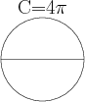

- A circle has an area of 32 square kilometers. What is the circumference of the circle?

- What is the area of the circle?
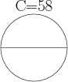

- What is the circumference of the circle?
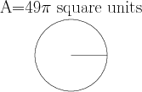

For problems 5 – 7, we are going to look at the area of a circle and how we can compare that to other circles:
- Captain Super Awesome Amazing Man is opening a pizzeria, “C-SAAM Pizza!” Using his super powers, he has decided that the small pizza should be $6. If Captain Super Awesome Amazing Man charges a constant amount per square inch, what are appropriate prices for the medium and large pizzas?
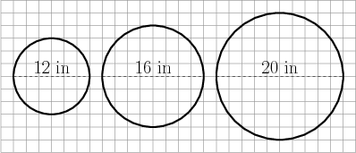

- Dr. Evil Bad Guy, PhD, is taking a break from being evil and is making cookies for the monthly evil villain meeting, which he has to host this month in his evil lair. It’s not really an evil lair, it’s actually just the basement of his parents’ house, where he lives. He’s rolling the dough into the square below, and is cutting circular cookies from the square.
a) If Dr. Evil Bad Guy cuts circular cookies that are 2 inches in diameter. How many cookies can
he cut without gathering the scraps? How much dough will be left over?

b) How much dough would be left over if Dr. Evil Bad Guy cuts one giant cookie 12 inches in
diameter?

c) How many cookies could he make from the leftovers?

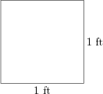

- Dribble Dee McGee is looking for a new sprinkler. He finds one posted on Amazon.com that says it will water a circle 500 square feet in area. Dribble Dee McGee’s yard is 40 ft x 10 ft. Will the sprinkler cover every inch of grass in his yard?

Problems 8 – 11 concentrate on the relationship between area & circumference, and how the relationship between the two can be used to solve other problems:
- Consider a circle that has a circumference of 28π centimeters (cm).

a) What is the area, in $cm^{2}$, of this circle? Show all work necessary to justify your response.

b) What would be the measure of the radius, in cm, of a circle with an area that is 20$\%$ greater
than the circle in part (a)? Show all work necessary to justify your response.

- Famous teeny-bopper, Johnny (I can’t sing) Meloddy is known for being a great host, and he puts a lot of time into preparing for events. For Johnny’s next event, he has ordered 100 dinner plates. Each plate is 12 inches in diameter, with gold trim along the edge (hey, you gotta represent). How much gold trim will Johnny Meloddy need?

- Mr. Scarvelli is biking around a huge satellite dish and jamming to some tunes (Miley Cyrus). His bike tires are 2 feet in diameter, and the dish he’s riding around is 1,000 feet in diameter. How many times does Mr. Scarvelli’s tires go round in one lap around the dish?

- In modern cataract surgery (phacoemulsification), the ophthalmologist makes an incision that is $6\%$ of the circumference of the cornea. If the diameter of a patient’s cornea is 8 mm, what is the length of the incision?

Homework.
- What is the circumference of the circle?
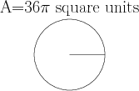

- Captain Super Awesome Amazing Man is opening a pizzeria, “C-SAAM Pizza!” Using his super powers, he has decided that the small pizza should be $4. If Captain Super Awesome Amazing Man charges a constant amount per square inch, what are appropriate prices for the medium and large pizzas?
- A circle has an area of 23 square inches. What is the circumference of the circle?

- What is the area of the circle?
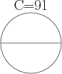

- Dr. Evil Bad Guy, PhD, is taking a break from being evil and is making cookies for the monthly evil villain meeting, which he has to host this month in his evil lair. It’s not really an evil lair, it’s actually just the basement of his parents’ house, where he lives. He’s rolling the dough into the square below, and is cutting circular cookies from the square.

a) If Dr. Evil Bad Guy cuts circular cookies that are 1.5 inches in diameter. How many cookies
can he cut without gathering the scraps? How much dough will be left over?

b) How much dough would be left over if Dr. Evil Bad Guy cuts one giant cookie 11 inches in
diameter?

c) How many cookies could he make from the leftovers?

- Dribble Dee McGee is looking for a new sprinkler. He finds one posted on Amazon.com that says it will water a circle 490 square feet in area. Dribble Dee McGee’s yard is 39 ft x 12 ft. Will the sprinkler cover every inch of grass in his yard?

- Famous teeny-bopper, Johnny (I can’t sing) Meloddy is known for being a great host, and he puts a lot of time into preparing for events. For Johnny’s next event, he has ordered 100 dinner plates. Each plate is 11 inches in diameter, with gold trim along the edge (hey, you gotta represent). How much gold trim will Johnny Meloddy need?

- Mr. Herman is biking around a huge satellite dish and jamming to some tunes (Justin Bieber). His bike tires are 1.75 feet in diameter, and the dish he’s riding around is 1,000 feet in diameter. How many times does Mr. Herman’s tires go round in one lap around the dish?

Application of Factoring & Expanding Linear Expressions

SWBAT: __________________________________________________
Standard 7.EE.1 Apply properties of operations as strategies to add, subtract, factor, and
expand linear expressions with rational coefficients

Look at the four diagrams below:
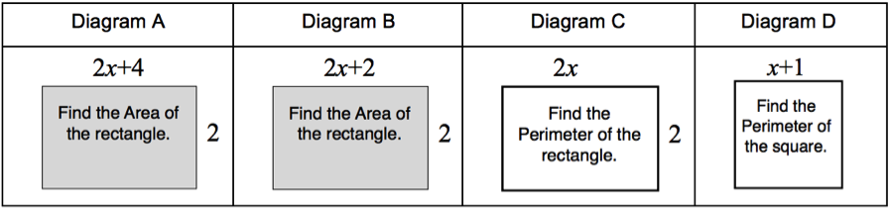
Diagram A
What is the area of the rectangle?

Diagram B
What is the area of the rectangle?

Diagram C
What is the perimeter of the rectangle?

Diagram D
What is the perimeter of the square?

Which diagram does not result in the expression 4x + 4? Explain your answer fully.

Find the area of the rectangle below:
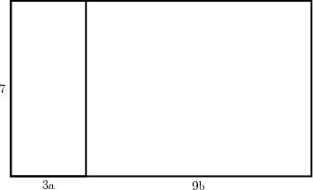

What are the base and height of the rectangle below?
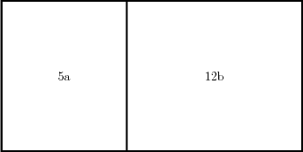
What are the base and height of the rectangle below?

16d

2s

A regular heptagon has a perimeter of 7x + 21. What is the length of each side?

A regular hexagon has a perimeter of 18x + 24. What is the length of each side?

A regular octagon has a perimeter of 16x – 8. What is the length of each side?

Homework.
- Find the perimeter and area of the rectangle below:

3x + 2

3

- Find the perimeter and area of the square below:

x + 2

- Find the perimeter and area of the rectangle below:

4

4a 2b
- Find the perimeter and area of the rectangle below:

2

3y 4x

- What are the base and height of the rectangle below?

10r

6w

- What are the base and height of the rectangle below?

12t

8p

- An equilateral triangle has a perimeter of 6x + 3. What is the length of each of its sides?

- A square has a perimeter of 24x + 12. What is the length of one of its sides?

- A regular pentagon has a perimeter of 5x + 10. What is the length of each of its sides?

