Name ______________________ Your score _________ Percent ______%

Unit 3 part I Study Guide Possible points _________ Grade ______

Proportions MELOTT
Show work on ALL problems
1. If $\frac{1}{2}$ gallon of paint covers $\frac{1}{8}$ of a wall, then how much paint is needed for the entire wall? | 2. If a person walks $\frac{1}{3}$ mile in each $\frac{1}{6}$ hour, compute the unit rate.
3. The table below gives the price of donuts in a donut store. Do the numbers in the table represent a proportional relationship?  Price/# songs= $3/1 book (fill in the blanks below)  Price/#songs= $ / 2 songs=(reduce) $ / books  Price/#songs= $ / 4 songs=(reduce) $ / books  Price/#songs= $ / 5 songs=(reduce) $ / books  Which of the following is a true statement?  Yes this is a proportional relationship b/c all fractions (are in the y/x format) and reduce to 3/1  OR  No, this is not a proportional relationship b/c not all fractions (are in the y/x format) nor reduce to 3/1. | 4. If total cost t is proportional to the number n of items purchased at a constant price p, the relationship between the total cost and the number of items can be expressed as t = pn. Use this theory to test if proportional relationship exists in the following table:  t= p*n  39 = p*1 (solve using inverse operations)  p=  78= p*2 (solve using inverse operations)  P=  117=p*3 (solve using inverse operations)  P=  153 = p*4 (solve using inverse operations)  p=  Which of the following is a true statement?  Yes this is a proportional relationship b/c all fractions (are in the t/n format) and reduce to the same number OR  No, this is not a proportional relationship b/c not all fractions (are in the t/n format) nor reduce to the same number.
  Number of songs purchased | Price
  1 | 3
  2 | 6
  4 | 12
  5 | 15
  Number of  burittos (n) | Total Cost (t)
  1 | 39
  2 | 78
  3 | 117
  4 | 153

5. The graph below represents the cost of lunchmeat per pound at one store. What is the constant of proportionality (how much do you pay per pound)?  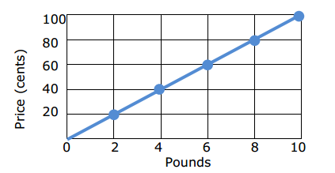 | 6. The price of pasta at another store can be determined by the equation:  P = 120n, where P is the price in cents and n is the number of pounds of pasta. What is the constant of proportionality (unit rate)?
7. A student is making Chex mix. Create a graph to determine if the quantities of Chex and pretzels are proportional for each serving size listed in the table.  If the quantities are proportional, what is the constant of proportionality or unit rate that defines the relationship?  Explain how the constant of proportionality was determined and how it relates to both the table and graph. | 8. The graph below shows the relationship between the number of liters of water consumed during a football practice and the number of days.  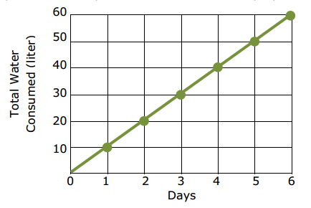  Select each statement about the graph that is true. Select all that apply.  - The point (0,0) shows that 0 liters of water was consumed at 0 days.  - The point (2,20) shows that 20 liters of water was consumed after 2 days.  - The point (3,30) shows that 3 liters of water were consumed after 30 days.  - The point (50,5) shows that after 5 days, 50 liters of water were consumed.  - The point (4,40) shows that after 4 days, 40 liters of water were consumed.
  Cups of Chex (x) | 1 | 2 | 3 | 4
  Cups of Pretzels (y) | 0 | 1 | 1.5 | 2

9. Ivy has a recipe that needs teaspoon of butter for every 4 cups of milk. If Sally increases the amount of milk to 5 cups of milk, how many teaspoons of butter are needed? Remember to set up the verbal model and use proportions to solve.
Create a verbal model first!

10. If the rectangle below is enlarged using a scale factor of 2.5, what will be the perimeter and area of the new rectangle?
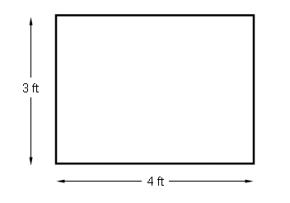

New Length:

New Width:

New Perimeter:

New Area:

12. The directions on a bottle of vinegar say, “mix two cups of vinegar with one gallon of water to make a cleaning solution.” The ratio of vinegar to water is 1 to 8.

Part A
How many cups of water should be mixed with ¼ cup of vinegar to make the cleaning solution?

Part B
How many fluid ounces of vinegar should be mixed with 80 fluid ounces of water to make the cleaning solution?

Part C
A bottle contains 1 pint of vinegar.
What is the total number of pints of cleaning solution that can be made using the entire bottle of vinegar?

Part D
A spray bottle holds up to 1 pint of the cleaning solution.
When the spray bottle is full, what fraction of the cleaning solution is vinegar?

