Common Core 7
Applications of Proportions (Unit 3 part I)
Mrs. Melott*, Mr. Rocco, Mr. Herman

Standard 7.RP.1

Compute unit rates associated with ratios of fractions, including ratios of lengths, areas and other quantities measured in like or different units.

Standard 7. RP.2

Recognize and represent proportional relationships between quantities.
a. Decide whether two quantities are in a proportional relationship, e.g., by testing for equivalent ratios in a table or graphing on a coordinate plane and observing whether the graph is a straight line through the origin.
b. Identify the constant of proportionality (unit rate) in tables, graphs, equations, diagrams, and verbal descriptions of proportional relationships. Represent proportional relationships by equations.
c. Explain what a point (x, y) on the graph of a proportional relationship means in terms of the situation, with special attention to the points (0, 0) and (1, r) where r is the unit rate.

Standard 7. RP.3

Use proportional relationships to solve multistep ratio and percent problems.

Standard 7. G.1

Solve problems involving scale drawings of geometric figures, including computing actual lengths and areas from a scale drawing and reproducing a scale drawing at a different scale.

This packet belongs to _________________________________________________

SWBAT: _____________________________________________________________
Standard 7.RP.1 Compute unit rates associated with ratios of fractions, including ratios of lengths, areas and other quantities measured in like or different units.

A _________________ is a comparison of two similar items. There are an infinite number of these.
Example:
● Teachers and Students=People
● Apples and Oranges= Fruit
● Cats and Dogs=Animals

When you compare two similar items you will have no units when you are finished.
There are 3 ways to write a ratio:
● Using the word to
● Using a colon (:)
● Writing a fraction (always reduce this to lowest terms!)

A _________________ is a comparison of two different quantities that are not similar. Rates usually deal with speed or money.
Example:
●Dollars per Item ($/item)
●Miles per Hour (mi/hr)
●Items per Minute (items/min)

When you compare two different items you will have the same units with which you started when you are finished.
*A _______ __________ is rate per 1 unit (denominator = 1).

This should look familiar…
1. If $\frac{1}{2}$ gallon of paint covers $\frac{1}{6}$ of a wall, then how much paint is needed for the entire wall? | 2. If a person walks $\frac{1}{2}$ mile in each $\frac{1}{4}$ hour, compute the unit rate.
3. Regina can read $\frac{1}{8}$ of a book in 2.5 days. How long will it take her to read the entire book? | 4. Penelope can swim $\frac{3}{8}$ of a mile in 7.25 minutes. How long will it take her to swim a mile?
5. A boa constrictor slithers ²/₆ kilometers in ⁴/₅ hours. What is its speed in terms of kilometers per hour? | 6. A dog runs ⁵/₇ kilometers in ⁴/₃₅ hours.  What is its speed in terms of meters per hour?

For each unit price, tell which one is a better buy:
7. 3 dozen binder clips for $2.88; 72 binder clips for $5.40

8. 14.5 gallons of gasoline for $50.08; 18.6 gallons of gas for $53.17

9. What is the ratio of the number of dimes in a dollar to the number of nickels in a dollar?

MINI LESSON (combine with Standard 7.RP.1)
SWBAT: ______________________________________________________________
Standard 7. RP.3 Use proportional relationships to solve multistep ratio and percent problems.

10. Sally has a recipe that needs teaspoon of butter for every 2 cups of milk. If Sally increases the amount of milk to 3 cups of milk, how many teaspoons of butter are needed?

11. Elaina has a recipe that needs teaspoon of butter for every 3 cups of milk. If Sally increases the amount of milk to 5 cups of milk, how many teaspoons of butter are needed?

12. A recipe calls for 2 ½ cups of flour to make 2 dozen cookies. How many cups of flour would you need to make 15 dozen cookies?

13. A crew of loggers felled and cleared ½ acre of lumber in four days. How long will it take the same crew to fell and clear 2 ¾ acres of lumber?

Homework. Show all steps in your spiral notebook OR staple a blank sheet in here
- A faucet fills a ⁵/₇-liter tub in ²/₆ minutes. What is its flow rate in terms of liters per minute?

- A waste company can process ⁵/₆ kilograms of garbage every ⁴/₃₀ hours. What is their speed in terms of kilograms per minute?

- Over a period of 3$\frac{1}{2}$hours, 211$\frac{3}{4}$ leaves fell from a tree. At this rate, how many leaves fell in one hour?

- Georgia drove a total of 252 miles and used 12$\frac{1}{2}$ gallons of gasoline. What is this rate in miles per gallon?

- Tyler scored 21 goals in 7 soccer games. What was the unit rate?

- While climbing down a mountain, Anthony descended 45$\frac{2}{3}$ feet every $\frac{1}{2}$hour. At this rate, how many feet will he descend in 6 hours?

- Which is the better buy? 12.5 gallons of gasoline for $45.08; 9.20 gallons of gas for $37.15.

- A recipe calls for 3 ½ cups of flour to make 4 dozen cookies. How many cups of flour would you need to make 16 dozen cookies?

- A recipe that serves 8 calls for 15 oz. of cooked tomatoes. How many oz. of cooked tomatoes will be needed if the recipe is reduced to serve 6? How many servings can be made with 20 oz. of cooked tomatoes?

- A certain soil mixture calls for 8 parts of potting soil to 3 parts of sand. To make the correct mixture, Holly used 0.672 kg of sand and 2 bags of potting soil. How much potting soil was in each bag?

SWBAT: _____________________________________________________________________
_____________________________________________________________________________
Standard 7. RP.2 Recognize and represent proportional relationships between quantities.
a. Decide whether two quantities are in a proportional relationship, e.g., by testing for equivalent ratios in a table or graphing on a coordinate plane and observing whether the graph is a straight line through the origin.
b. Identify the constant of proportionality (unit rate) in tables, graphs, equations, diagrams, and verbal descriptions of proportional relationships. Represent proportional relationships by equations.
c. Explain what a point (x, y) on the graph of a proportional relationship means in terms of the situation, with special attention to the points (0, 0) and (1, r) where r is the unit rate.

Example: The table below gives the price for different numbers of books. Do the numbers in the table represent a proportional relationship? You can test this by checking for equivalent ratios in a table or graphing on a coordinate plane and observing whether the graph is a straight line through the origin.
Number of Books | Price
1 | 3
3 | 9
4 | 12
7 | 18
Equivalent Ratios Graph
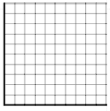

Tell whether the tables below represent a proportional relationship. Use both methods shown above. Explain why they do or do not.
1. Graph
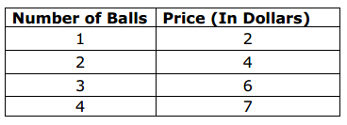

Equivalent ratios

Tell whether the tables below represent a proportional relationship. Use both methods shown above. Explain why they do or do not.
2. Graph
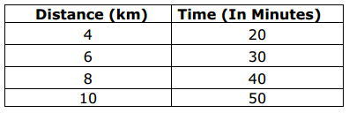

Equivalent ratios

3. Graph
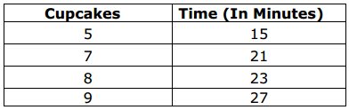

Equivalent ratios

4. If total cost c is proportional to the number n of items purchased at a constant price p, the relationship between the total cost and the number of items can be expressed as c = pn. Use this theory to test if proportional relationship exists in the following table:
Number of  Shirts (n) | Total Cost (c)
2 | 58
4 | 116
5 | 145

***The Constant of proportionality is the same as the unit rate.***
The constant of proportionality for the problem above is __________________.
The unit rate for the problem above is _____________________.

5. Andrea is a florist. The table below shows the number of flowers sold over the last few days. Use the equation you learned about above to find the constant of proportionality.
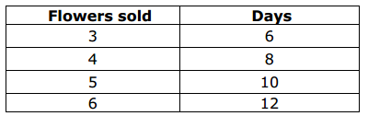

6. Given an equation in the form y = kx, you can identify the constant of proportionality = k. The price of apples at a store can be determined by the equation: P = $0.35n, where P is the price and n is the number of pounds of apples. What is the constant of proportionality (unit rate)?

7. The number of downloads on i-tunes can be determined by the equation D = 250x, where D is the total number of downloads and x is the number of downloads per second. What is the constant of proportionality or unit rate?

Homework: show all work
Tell whether the tables below represent a proportional relationship. Use both equivalent ratios and make a graph. Explain why they do or do not.
1. Graph
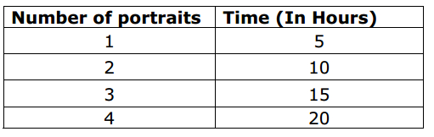

Equivalent ratios

Explain:

2. Graph
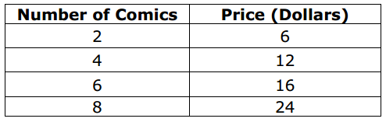

Equivalent ratios

Explain:

Homework continued
3. A ferry has to transport bikes on an island. The table below shows the number of bikes transported and the number of trips made by the ferry. Use the equation y = kx, that you learned about in the lesson to find the constant of proportionality.
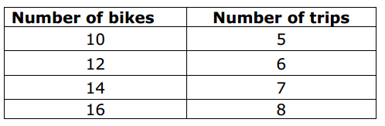

4. The table below shows the amount earned by Harry for selling cups of ice cream. Use the equation y = kx, that you learned about in the lesson to find the constant of proportionality.
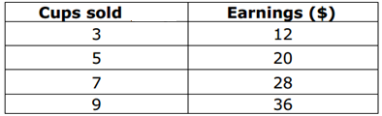

5. The price of tires at a store can be determined by the equation: P = $74n, where P is the price and n is the number of tires. What is the constant of proportionality (unit rate)?

6. The price of hats at a store can be determined by the equation: P = $7n, where P is the price and n is the number of hats. You will need to use a separate sheet of graph paper for this problem.
a. What is the constant of proportionality (unit rate)?

b. Make a table with the number of hats equal to 1, 2, 3, 4 & 5. Complete the table for P, the price of the hats.

c. Make a graph of your table above.

c. Is it possible for there to be a total number of hats that costs $91? Explain your answer.

SWBAT: _____________________________________________________________________
_____________________________________________________________________________
Standard 7. RP.2 Recognize and represent proportional relationships between quantities.
a. Decide whether two quantities are in a proportional relationship, e.g., by testing for equivalent ratios in a table or graphing on a coordinate plane and observing whether the graph is a straight line through the origin.
b. Identify the constant of proportionality (unit rate) in tables, graphs, equations, diagrams, and verbal descriptions of proportional relationships. Represent proportional relationships by equations.
c. Explain what a point (x, y) on the graph of a proportional relationship means in terms of the situation, with special attention to the points (0, 0) and (1, r) where r is the unit rate

Take a look at the graph below. Look at point B. Susan runs four laps at the track in 1 minute.
1. Explain the meaning of point A (0,0):
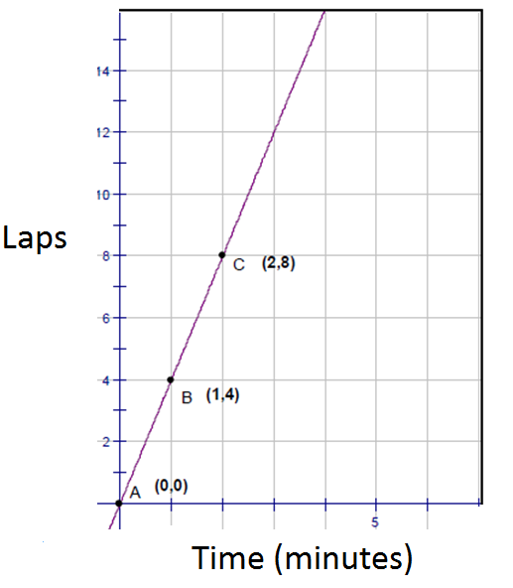

2. Explain the meaning of point C (2,8):

3. How many laps does Susan run in 3 minutes?

4. How long does it take Susan to run 6 laps?

5. What is the unit rate for Susan?

Making a table and graph based on a relationship
1. Complete the ratio table below for the following statement, “One out of three students at Learwood Middle School take Spanish.”
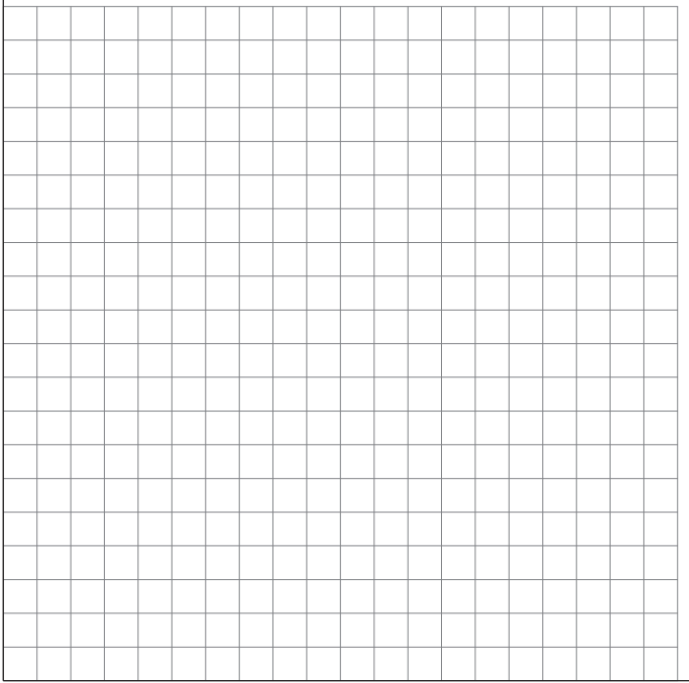
Spanish | 1
Total | 3

a. What is the unit rate for this relationship?

b. How many students are in school if zero
students take spanish?

c. Make a graph for the table. Using a straight
edge, draw a line through all the points. Notice
that the line goes through point (0,0). What does
this mean?

d. What does the ordered pair (5,15) tell us?

-----------------------------------------------------------------------------------------------------------------------------------
2. Create a ratio table below for the following statement, “Tracy can ride her bike 30 miles in 3 hours.”

a. What is the unit rate for this relationship?

b. How many miles did she ride after 2 hours?

c. Make a graph for the table. Using a straight
edge, draw a line through all the points. Notice
that the line goes through point (0,0).

d. What does the ordered pair (5,50) tell us?

3. Create a ratio table below for the following statement, “To make a brownie mix, you need ½ cup of sugar for every package of mix.”

a. What is the unit rate for this relationship?

b. How many cups of sugar do you need for
5 packages of mix?

c. Make a graph for the table. Using a straight
edge, draw a line through all the points. Notice
that the line goes through point (0,0).

d. What does the ordered pair (4,8) tell us?

4. Create a ratio table below for the following situation. A vine grows 2.5 feet every 3.5 days.

a. What is the unit rate for this relationship?

b. Make a graph for the table. Using a straight
edge, draw a line through all the points.

c. How tall is the plant after 10 days?

d. Is the length of the vine on the last day
proportional to the number of days of growth?

Homework
1. Complete the ratio table below for the following statement. An adult elephant drinks about 225 liters of water per day.
Time (days) | 1
Water (liters) | 225

a. How many liters of water does the elephant
drink in 4 days?

b. Make a graph for the table. Using a straight
edge, draw a line through all the points.

c. Does this represent a proportional relationship?
If so, what is the unit rate for this relationship?

d. What does the ordered pair (4,900) tell us?

---------------------------------------------------------------------------------------------------------------------------------------2. Which situation below represents a proportional relationship between the number of laps run by each student and their time? To find out, make a graph of each. Explain which one shows a proportional relationship.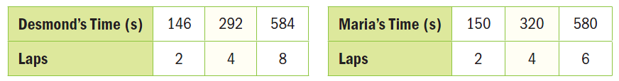

3. Plant A is 18 inches tall after 1 week, 36 inches tall after two weeks, and 56 inches tall after three weeks. Plant B is 17 inches tall after 1 week, 25.5 inches tall after two weeks, and 34 inches tall after three weeks. Make a graph to determine which plant represents a proportional relationship between the plants’ height and the number of weeks.
Plant A Plant B

4. The greenhouse temperatures at certain times are shown in the table below. The greenhouse maintains temperatures between 65 degrees F and 85 degrees F. Suppose the temperature increases at a constant rate. Create a graph of the time and temperatures at each hour from 1:00 p.m. to 8:00 p.m. Is the relationship proportional? Explain using complete sentences.
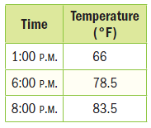

SWBAT: _____________________________________________________________________

Standard 7. G.1

Solve problems involving scale drawings of geometric figures, including computing actual lengths and areas from a scale drawing and reproducing a scale drawing at a different scale.

Scale Drawings
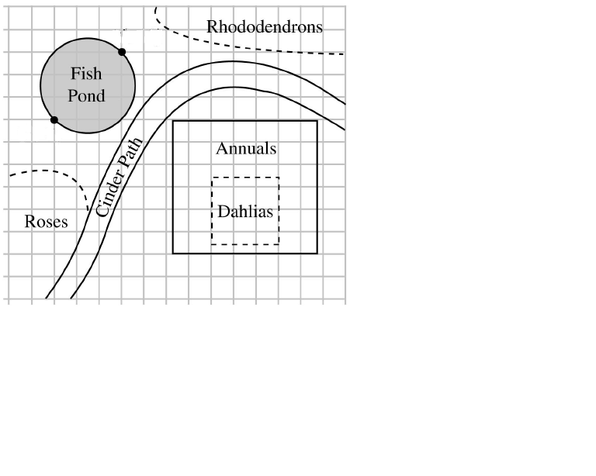
Use the scale drawing of the garden above to answer the following questions.

1) What are the approximate dimensions of the actual yard?

2) About how wide is the actual path?

3) Approximately how far is it across the actual fish pond?

$$\frac{1}{4}inch=3 feet$$
Scale drawings are used to represent actual things in real life. In the example to the left, a landscape architect planned out a garden on paper before any work in the yard was done. This gives the architect a plan to use when the actual yard is worked on.
The scale of a drawing is the ratio of the drawing length to the actual length in real life.
The scale for the garden drawing is written below it. Each small square on the grid = ¼ of an inch.

You can also use a scale factor to find missing measurements in real life. Try the problems below. Remember to always put the drawing dimension on the top and the actual dimension on the bottom.
Hint $\frac{drawing}{actual}$

Example 1
On a scale drawing, a house is 12 in long. The actual house is 50 ft long. On the drawing, the window is 2.5 inches tall. How many feet tall is the actual window?

Example 2
A drawing of a skyscraper is 11.2 inches high. The scale factor is 8 inches = 250 feet. What is the actual height of the skyscraper?

Example 3
A Florida map has a scale of 1 inch = 22.8 miles. If the actual distance between Vero Beach and Boynton Beach is 79.8 miles, what is the distance on the map between the 2 cities?

Example 4
Blueprints of a house are drawn to the scale of ¼ in = 1 ft. Its kitchen measures 3.5 inches by 5 inches on the blueprints. What are the actual dimensions of the kitchen?

Example 5
On a scale drawing of a white shark, the scale is 2 in = 15 ft. If the actual shark is 38 ½ feet long. How long is the drawing of the shark?

Example 6
Dexter makes a scale drawing of his room. In real life, the actual room is 10' wide and 12' 6" long. In Dexter’s drawing, the room is 4" wide. What measure should the length be on the drawing?

Homework

1. A scale drawing has a scale of 1 in. = 10 ft. How long is a line on the drawing that represents an actual length of 22.5 feet?

2. On a map, the distance between Charleston and Mt. Pleasant is 3.2 cm. What is the actual distance between the two towns if the scale of the map is 1 in. = 15 mi?

3. The actual distance between Atlanta and Nashville is 250 miles. What is the distance between the two cities on a map with a scale of 1 in. = 20 mi?

4. Blueprints of a house are drawn to the scale of ¼ in. = 1 ft. A bedroom measures 4 in. by 5 in. on the blueprint. What are the actual dimensions of the bedroom?

5. A scale drawing of the Space Needle in Seattle, Washington has a scale of 1:110. The height of the Space Needle is 605 feet. Find the height of the drawing.

6. On a map, the distance between two cities is 4 ½ inches. What is the actual distance in miles between the two cities if the map’s scale is 1 in. = 80 mi?

7. You are making a scale drawing of a football stadium. The drawing has a scale of 12 in. = 480 ft. The actual length of the football field including the end zones is 120 yards.

- How long in inches is the football field on the drawing?

- How many times larger is the actual stadium compared to the drawing?

- The length of the drawing is 18 inches. How long in yards is the actual stadium?

8. A building is drawn with a scale of 1 in. = 3ft. The height of the drawing is 1 ft 2 in. After a design change, the scale is modiﬁed to be 1 in. = 4 ft. What is the height of the new drawing?

More with Scale Drawings
Mrs. Housebuilder wants to have a new house built. She used graph paper to sketch some thoughts for a possible floor plan for her house. The bold outline in the figure below represents the outline of the first floor of the house. The scale of the drawing is ¼ in. = ½ ft. Each of the small squares is ¼ inch.

1. What is the perimeter of the room labeled Bath #1 on the drawing?

2. What is the perimeter of the actual bathroom?

3. What is the area of the living room on the drawing?

4. What is the area of the actual living room?

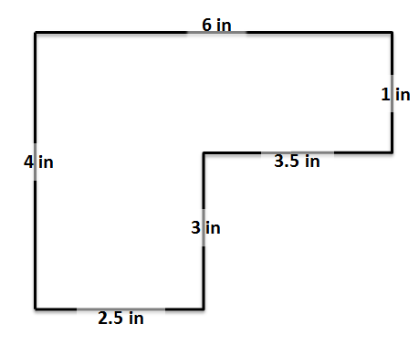
Britney made a scale drawing of her bedroom. The scale is marked below the drawing.
5. What is the length of the actual wall that measures 4 inches on the drawing?

6. What is the length of the actual wall that measures 2.5 inches on the drawing?
Scale
2 in. = 5 ft.

7. A square has a perimeter of 60 ft. A scale drawing of the figure is made with a scale of 1/3 in. = 5 ft. What is the perimeter of the scale drawing of the square?

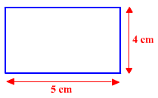
8. The rectangle to the right is enlarged using a scale factor of 1.5.

a) What is the new perimeter of the rectangle?

b) What is the new area of the rectangle?

c) Draw the new rectangle using a ruler.

9. Blueprints of a house are drawn to the scale of ¼ in. = 1 ft. A bedroom measures 4 in. by 5 in. on the drawing. What is the actual area of the bedroom?

10. A scale drawing of a square with an area of 144 ft² is made using a scale of ½ in. = 3 ft.

a) What is the area of the square on the scale drawing?

b) Use a ruler to make the scale drawing of the square below.

Homework

Use the scale drawing of the house below for questions 1 – 4. The scale is 4 cm. = 2 ½ ft.
1. What is the length of the actual wall of the house that measures 40 cm?

2. What is the length of the actual wall of the house that measures 25 cm?

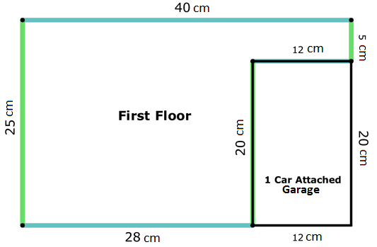

3. The area of the 1 Car Attached Garage is 12 cm. by 20 cm. on the drawing. What is the area of the actual garage?

4. You can find the perimeter of the house by adding up all of the sides around it. What is the perimeter of the house in the drawing? What is the perimeter of the actual house?

5. The rectangle to the right is enlarged using a scale factor of 1.25
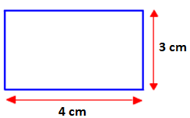

a) What is the new perimeter of the rectangle?

b) What is the new area of the rectangle?

c) Draw the new rectangle below using a ruler.

6. The area of a rectangle is 216 ft². The length of the rectangle is 18 ft. If a scale drawing of the rectangle has a scale of ½ in. = 6 ft., what is the area of the rectangle in the scale drawing?

7. Mariko has a scale drawing of the floor plan of her house. The scale is ½ in. = 3 ft. On the floor plan, the dimensions of her rectangular living room are 1 7/8 inches by 2 ½ inches. What is the area of her real living room in square feet?

8. The drawing below is of Jessie’s bedroom.
If each 1 in on the scale drawing equals 3 ft., what are the actual dimensions of Jessie’s room?

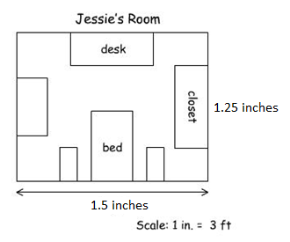

SWBAT: _____________________________________________________________________

Standard 7. RP.3

Use proportional relationships to solve multistep ratio and percent problems.
Ratios and multistep problems
Let’s try this problem from the PAARC website…
A restaurant makes a special seasoning for all its grilled vegetables. Here is how the ingredients are mixed:
When the ingredients are mixed in the same ratio as shown to the left, every batch of seasoning tastes the same.
Study the measurements for each batch in the table. Fill in the blanks in the table below so that every batch will taste the same.
12 of the mixture is salt
14 of the mixture is pepper
18 of the mixture is garlic powder
18 of the mixture is onion powder

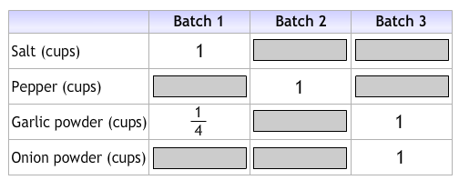
The restaurant mixes a 12-cup batch of the mixture every week. How many cups of each ingredient do they use in the mixture each week?
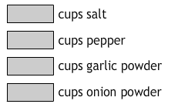

Example 2
Travis was attempting to make muffins to take to a neighbor that had just moved in down the street. The recipe that he was working with required 3/4 cup of sugar and 1/8 cup of butter.

Travis accidentally put a whole cup of butter in the mix. Oops!

- What is the ratio of sugar to butter in the original recipe?

- What amount of sugar does Travis need to put into the mix to have the same ratio of sugar to butter that the original recipe calls for?

- If Travis wants to keep the ratios the same as they are in the original recipe, how will the amounts of all the other ingredients for this new mixture compare to the amounts for a single batch of muffins?

- The original recipe called for 3/8 cup of blueberries. What is the ratio of blueberries to butter in the recipe? How many cups of blueberries are needed in the new enlarged mixture?

- This got Travis wondering how he could remedy similar mistakes if he were to dump in a single cup of some of the other ingredients. Assume he wants to keep the ratios the same

- How many cups of sugar are needed if a single cup of blueberries is used in the mix?

- How many cups of butter are needed if a single cup of sugar is used in the mix?

- How many cups of blueberries are needed for each cup of sugar?

Homework
- Lindsay was attempting to make muffins to take to a neighbor that had just moved in down the street. The recipe that she was working with required 5/8 cup of sugar and 1/4 cup of butter.
Lindsay accidentally put a whole cup of butter in the mix. Oops!

- What is the ratio of sugar to butter in the original recipe?

- What amount of sugar does Lindsay need to put into the mix to have the same ratio of sugar to butter that the original recipe calls for?

- If Lindsay wants to keep the ratios the same as they are in the original recipe, how will the amounts of all the other ingredients for this new mixture compare to the amounts for a single batch of muffins?

- The original recipe called for 3/8 cup of blueberries. What is the ratio of blueberries to butter in the recipe? How many cups of blueberries are needed in the new enlarged mixture?

- This got Lindsay wondering how she could remedy similar mistakes if she were to dump in a single cup of some of the other ingredients. Assume she wants to keep the ratios the same.
- How many cups of sugar are needed if a single cup of blueberries is used in the mix?

- How many cups of butter are needed if a single cup of sugar is used in the mix?

- How many cups of blueberries are needed for each cup of sugar?

- The directions on a bottle of ammonia say, “mix 4 cups of ammonia with one gallon of water to make a cleaning solution.” The ratio of ammonia to water is 1 to 4.

- How many cups of water should be mixed with ¼ cup of ammonia to make the cleaning solution?

- How many fluid ounces of ammonia should be mixed with 60 fluid ounces of water to make the cleaning solution?

- A bottle contains 1 quart of ammonia. What is the total number of quarts of cleaning solution that can be made using the entire bottle of ammonia?

- A spray bottle holds up to 1 quart of the cleaning solution. When the spray bottle is full, what fraction of the cleaning solution is ammonia?

