Name ______________________ Your score (#points) _________
Pre-test Possible points 29

Unit 3 Part I Proportions (MELOTT)
Show work on ALL problems
1. If $\frac{1}{2}$ gallon of paint covers $\frac{1}{6}$ of a wall, then how much paint is needed for the entire wall? Don’t forget your units! | 2. If a person walks $\frac{1}{2}$ mile in each $\frac{1}{4}$ hour, compute the unit rate. UNITS!
3. The table below gives the price for different numbers of books. Do the numbers in the table represent a proportional relationship? You can test this by checking for equivalent ratios in a table or graphing on a coordinate plane and observing whether the graph is a straight line through the origin.  Price/# books= $3/1 book (fill in the blanks below)  Price/#books= $ / 3 books=(reduce) $ / books  Price/#books= $ / 4 books=(reduce) $ / books  Price/#books= $ / 7 books=(reduce) $ / books  Which of the following is a true statement?  Yes this is a proportional relationship b/c all fractions (are in the y/x format) and reduce to 3/1  OR  No, this is not a proportional relationship b/c not all fractions (are in the y/x format) nor reduce to 3/1. | 4. If total cost t is proportional to the number n of items purchased at a constant price p, the relationship between the total cost and the number of items can be expressed as t = pn. Use this theory to test if proportional relationship exists in the following table:  t= p*n  58 = p*2 (solve using inverse operations)  p=  116= p*4 (solve using inverse operations)  P=  125=p*5 (solve using inverse operations)  P=  Which of the following is a true statement?  Yes this is a proportional relationship b/c all fractions (are in the t/n format) and reduce to the same number OR  No, this is not a proportional relationship b/c not all fractions (are in the t/n format) nor reduce to the same number.
  Number of Books | Price
  x | y
  1 | 3
  3 | 9
  4 | 12
  7 | 18
  Number of  Shirts (n) | Total Cost (t)
  2 | 58
  4 | 116
  5 | 125

5. The graph below represents the price of the bananas at one store. What is the constant of proportionality (how much do you pay per pound)?  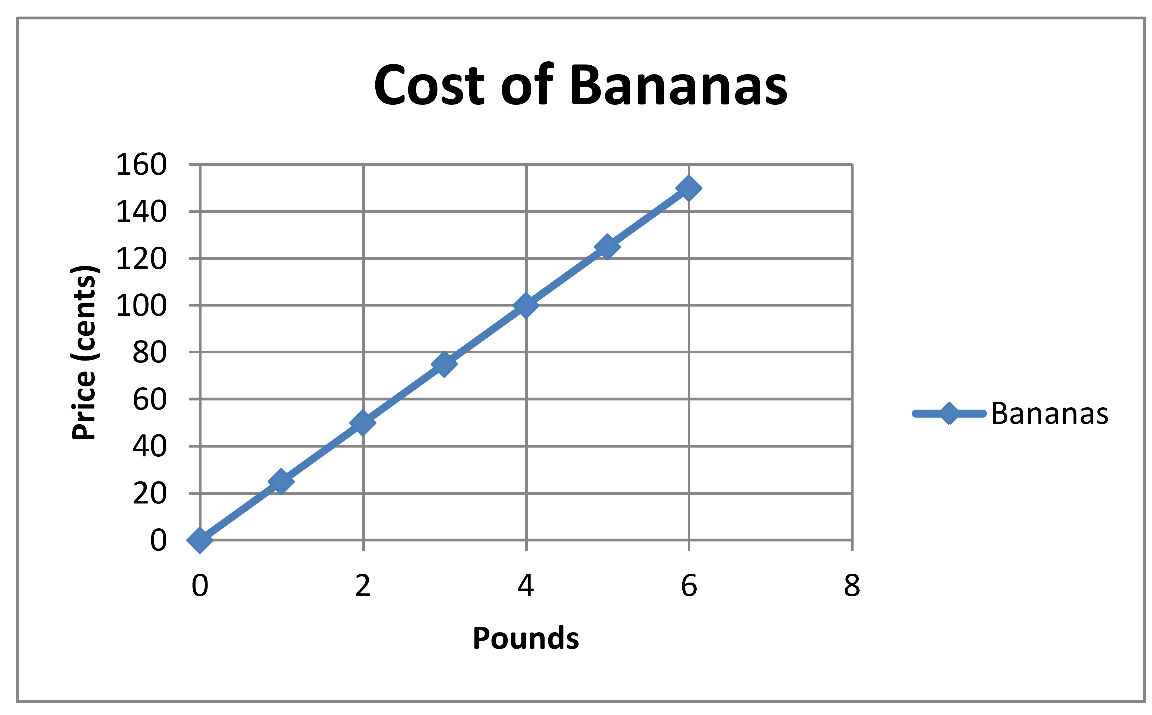 | 6. The price of grapes at another store can be determined by the equation:  P = $0.35n, where P is the price and n is the number of grapes. What is the constant of proportionality (unit rate)—how much do you pay per pound?
7. A student is making Chex mix. Create a graph to determine if the quantities of Chex and pretzels are proportional for each serving size listed in the table.  If the quantities are proportional, what is the constant of proportionality or unit rate that defines the relationship?  Explain how the constant of proportionality was determined and how it relates to both the table and graph. | Equation:
  Cups of Chex (x) | 1 | 2 | 3 | 4
  Cups of pretzels (y) | 2 | 4 | 6 | 8

9/10. Sally has a recipe that needs teaspoon of butter for every 2 cups of milk. If Sally increases the amount of milk to 3 cups of milk, how many teaspoons of butter are needed?
Create a verbal model first!

10. If the rectangle below is enlarged using a scale factor of 1.5, what will be the perimeter and area of the new rectangle?

